Exercise 3.1

Part 1
Input | Output | t_{pd_LH} | t_{pd_HL}
Low-high | High-low | N/A | 0.07757 ns
High-low | Low-high | 0.0907 ns | N/A

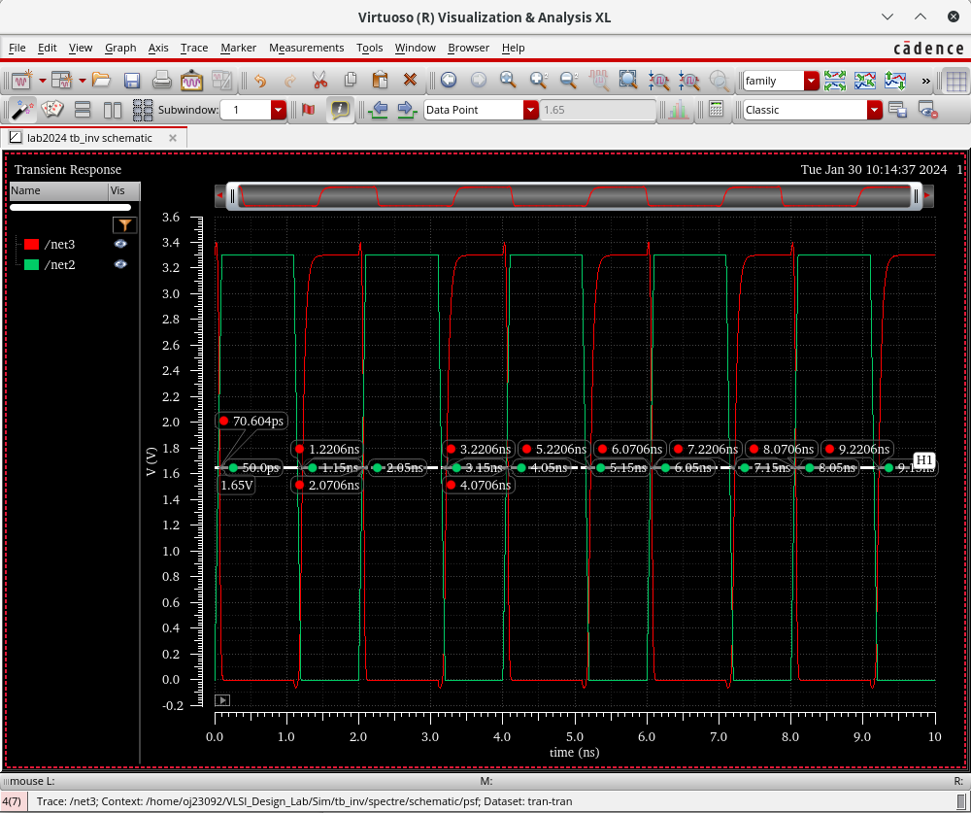

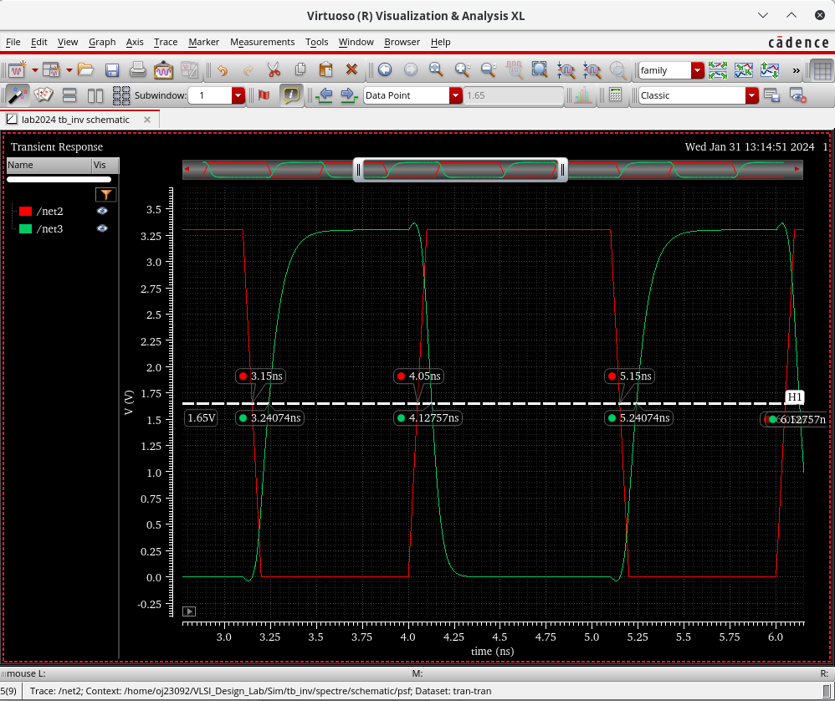

Red is input, and Green is output in the above simulation plot.

Part 2
equivalent circuit at the back of ODS notebook

Part 3

Derivation: In ODS notebook (back)

t_{pd_LH} = 0.69*R_{p}*C_{L}
t_{pd_LH} = 0.0907 ns
C_{L} = 12 fF
R_{p} = 10954.1 Ω

Part 4

(Analytic result)

R_{p} = R_{p, min} x W_{min}/W x L/L_{min}

R_{p, min} = 10954.1 x 1/1 * 0.35/0.35 = 10954.1 Ω = 10.954 kΩ

(After Simulation)

Input | Output | t_{pd_LH} | t_{pd_HL}
Low-high | High-low | N/A | 0.06953 ns
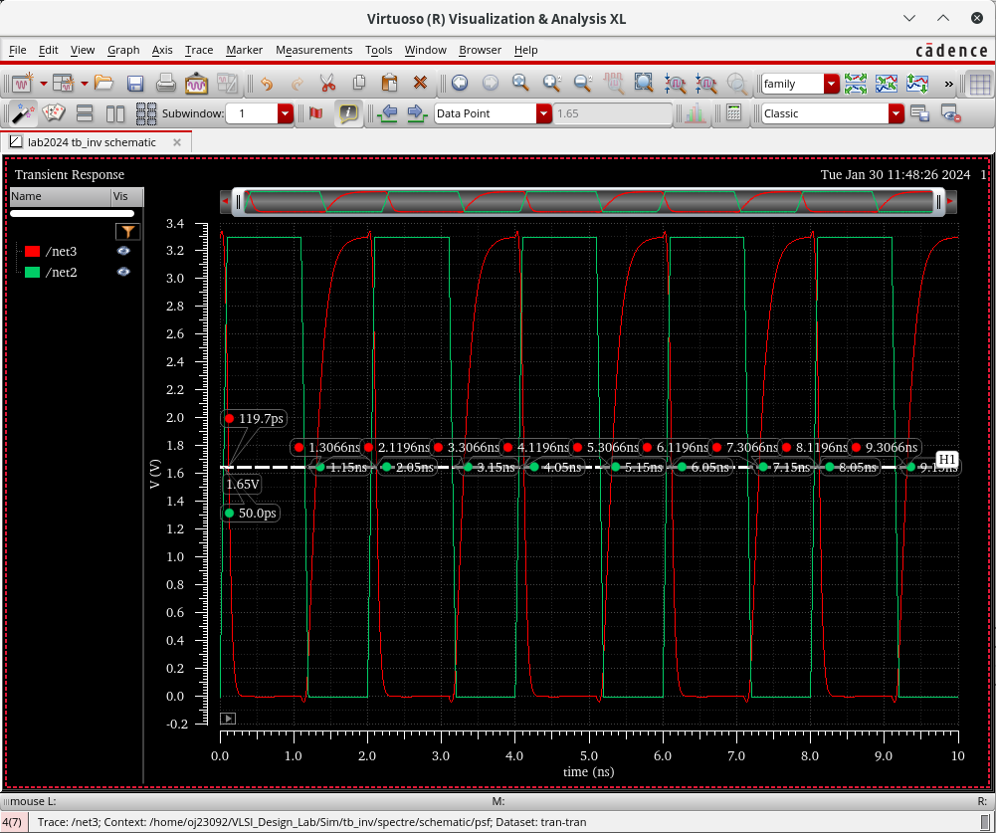  High-low | Low-high | 0.15645 ns | N/A

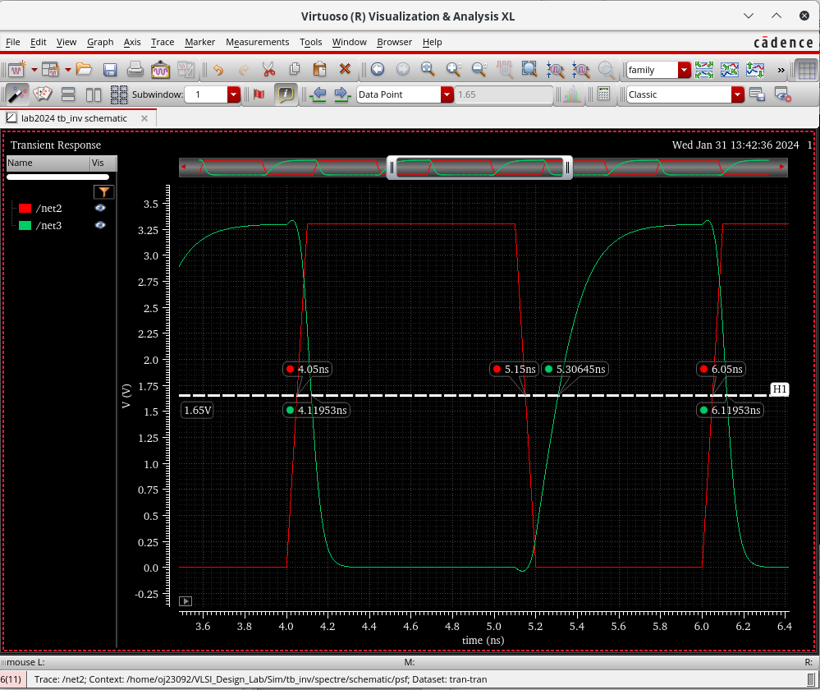

Output is Green, and Input is Red in the above simulations.

R_{p} = 18894.93 Ω = 18.895 kΩ

R_{p, min} = 18894.93 Ω = 18.895 kΩ

Part 5

t_{pd_HL} = 0.69 x R_{n} x C_{L}

R_{n} = 9368.36 Ω = 9.368 kΩ

R_{n, min} = 9368.36 * 1/1 * 0.35*0.35 = 9368.36 Ω = 9.368 kΩ

___
Note: Recheck values of width and length for part 2, 3

Exercise 3.2
Part 1
(See ODS Notebook for derivation values)
PMOS W/L = 3.259/0.35 (mu m)
NMOS W/L = 1.61/0.35 (mu m)

Part 2
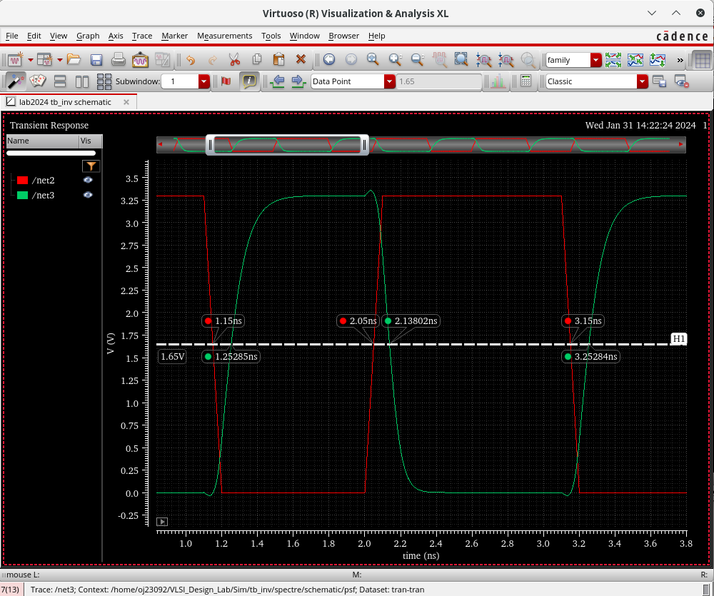

Input | Output | t_{pd_LH} | t_{pd_HL}
Low-high | High-low | N/A | 0.08802 ns = 88.02 ps
High-low | Low-high | 0.1028 ns = 102.8 ps | N/A

